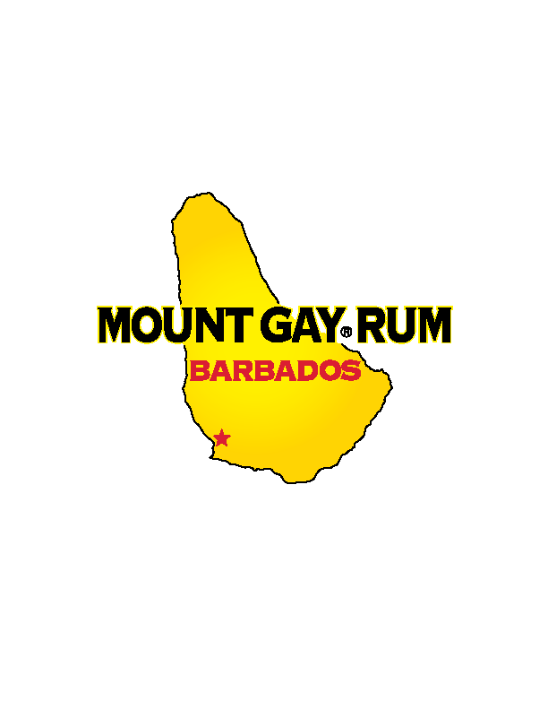
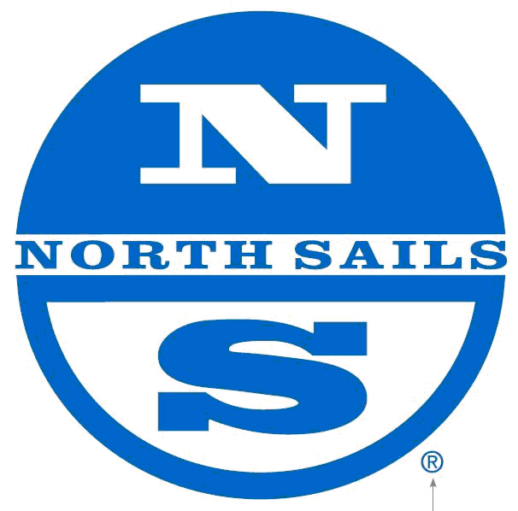
- RULES: The Regatta shall be governed by the International Sailing Federation Racing Rules of Sailing 2009 -2012, the prescriptions of US Sailing and the rules of each Class concerned, except as any of these are modified by the Notice of Race, and by the Sailing Instructions (and any amendments thereto). The Regatta is subject to the Advertising restrictions as defined in RRS Appendix 1 (Advertising). Those classes satisfying Appendix 1 qualifications for Category C may carry advertising subject to the restrictions of Appendix 1, Category C. All racing will be on a boat-for-boat basis with no handicaps applied, except the IRC Division(s), some PHRF Divisions as noted, Offshore Multihull Division(s) and the No Flying Sails Division(s), which will be scored based on PHRF handicaps or converted equivalents utilizing the time on time method.

- ELIGIBILITY: The Regatta is open to all yachts in classes that meet the minimum requirement of five registered yachts, and for all yachts with a PHRF or IRC certificate.

- SCHEDULE OF EVENTS:
- Registration from 1200 to 2300 hours on Friday, July 22 and from 0700 to 0800 hours on Saturday, July 23.
- Racing on five (5) course areas on Sat, July 23 and Sun, July 24.
- The first warning signal will be 1000 hours each day.
- Live entertainment will be provided Friday & Saturday nights and Sunday afternoon.
- Awards presented at approximately 1600 hours on July 24, or as soon as possible following that day's racing.

- REGISTRATION: Complete the entry form online at: http://www.yachtscoring.com (preferred)
or, send it together with the required entry fee to: Youngstown Yacht Club
PO Box 379
Youngstown, NY 14174
If registering by mail you must also Fax entry form to 716-745-7365

Yacht Length | Entry Fee | Number of Wristbands Included
up to 25' | 145 | 3
26'-29' | 195 | 5
30'-34' | 225 | 6
35' -39' | 265 | 7
40' and Over | 285 | 8
Additional Wristbands are available for $15 each with pre-registration
Pre-registration closes at 2400 hours on July 21, 2011. A $45 late surcharge shall apply to entries received after July 21. Registration will reopen at 1200 hours on Friday, July 22, 2011. A representative from each yacht must sign in with the registrar prior to 0730 hours on July 23 before being deemed eligible for competition.

- WRISTBANDS: A wristband must be purchased for each person attending the regatta, including guests. Discount wristbands ($15 US) are available only through pre-registration until 2400 hours on July 21, 2011. Additional wristbands will only be available at the wristband tent at the general admission price ($25 US).

- SKIPPER’S MEETING & INSPECTION: No skipper’s meeting will be held. Yachts will not be inspected. Each owner skipper shall be responsible for having the safety equipment aboard required by the Country and State or Province of registry.

- SAILING INSTRUCTIONS: Available from http://www.yachtscoring.com and they will be distributed at the YYC Regatta Office after 1200 hours on July 22, 2011.

- COURSES: Five courses on Lake Ontario off the Niagara River will be set using inflatable marks around closed courses selected by the Race Committee.

- SCHEDULE OF RACES: It is the intent of the Organizing Authority and the Race Committee to run as many races as practical on each day of racing up to a maximum of eight (8) races for the event. No starting sequence will commence after 1430 hrs on Sunday, July 24.

- PENALTY SYSTEMS: For all divisions, except the 8 Metres, the Two-Turns Penalty (rules 44.1 and 44.2) shall apply. For the 8 Metres, the 20% scoring Penalty (rule 44.3) shall apply.

- SCORING: The low-point scoring system, rule A4 shall apply, and is modified so that each boat's series score will be the total of her race scores with no scores discarded.

- ARBITRATION: For protests involving an infringement of a Rule of Part 2 of the RRS, an Arbitration hearing may be held prior to the protest hearing.

- HAUL-OUT RESTRICTIONS: Free launching and haulout for boats up to 40’ will be available. During the regatta yachts may only be hauled with written permission of the Race Committee, bottoms may not be cleaned.

- DIVISION ASSIGNMENTS: The Regatta Committee has the final say as to which division a yacht shall compete in. Available ratings and other data will be used to assign yachts to divisions. Our preference is to have as many boats racing level (without handicap allowances) as possible, but some divisions, such as IRC and certain PHRF and NFS divisions, will use handicap ratings and time allowances will be applied.

- SPORTSMANSHIP: The regatta organizers reserve the right to deny participation to any yacht or individual for unsportsmanlike behavior by any crewmember either on the water or on the grounds or in the vicinity of the Youngstown Yacht Club.

- PRIZES: Prizes will be awarded by class.

- DISCLAIMER OF LIABILITY: Competitors participate in the regatta entirely at their own risk. See RRS rule 4, Decision to Race. The organizing authority will not accept any liability for material damage or personal injury or death sustained in conjunction with or prior to, during, or after the regatta.

- INSURANCE: Each participating boat shall be insured with valid third-party liability insurance.

- FURTHER INFORMATION: For further general information, contact the Youngstown Yacht Club, PO Box 379, Youngstown, NY 14174, (716) 745-7230. For further information on eligibility and participating classes, contact Don Finkle (716) 695-4328 or don@rcryachts.com




- ENTERING THE USA BY BOAT: In order to expedite entry into the US, all visiting skippers should complete the US Customs and Border Protection Pre-Arrival Form available under Additional Documents on the registration page and forward them to patricia.janicki@dhs.gov. Groups that complete the pre-arrival forms will be given priority clearance to land. Please note that border clearance is in the Regatta Office.

